**EBS (ELASTIC BLOCK STORE)**

Amazon Elastic Block Store (Amazon EBS) provides scalable, high-performance block storage resources that can be used with Amazon Elastic Compute Cloud (Amazon EC2) instances.

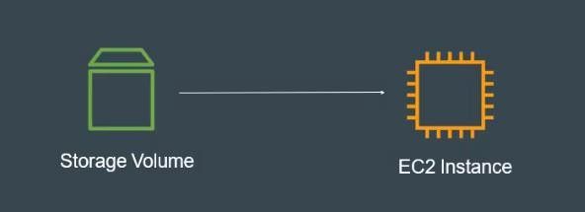

* **Create EBS and attach EBS to 3 different Instances**
* Open AWS account and Create an Instance

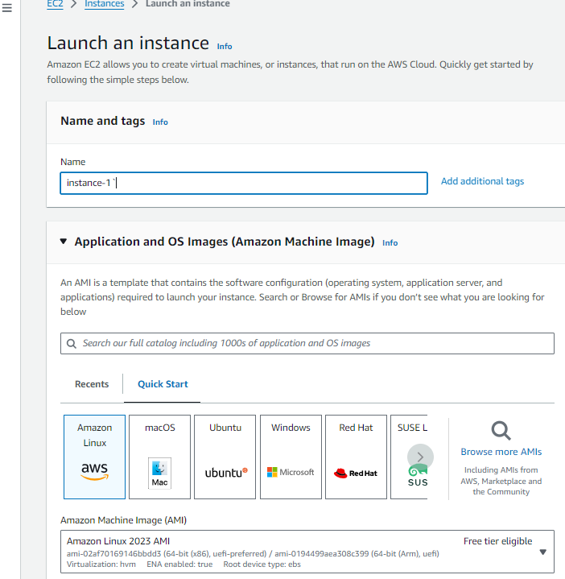

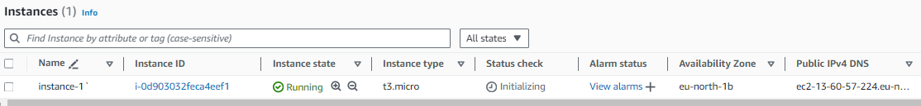

* Once created the instance copy the ssh command and connect with that in git bash to the server.
* After that change to the root user with sudo su command and then check the disk free space with the command df -h as shown in below.
* In AWS EC2 instance have 8GB default storage.
* Create two more instance with same availability zone and name as instance2 and instance 3

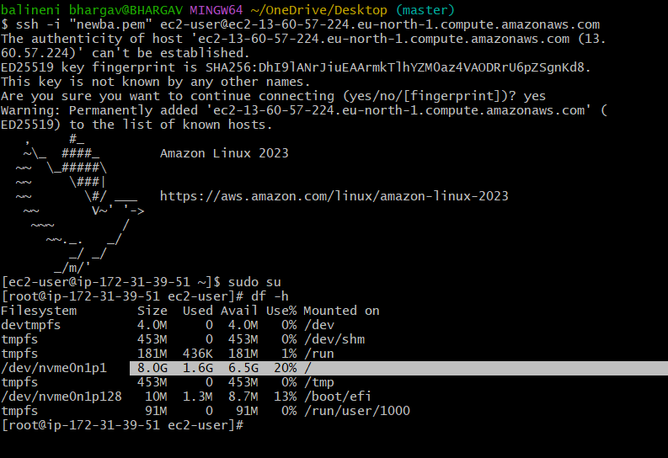

* Go to Elastic block store and click on volumes as shown in below.

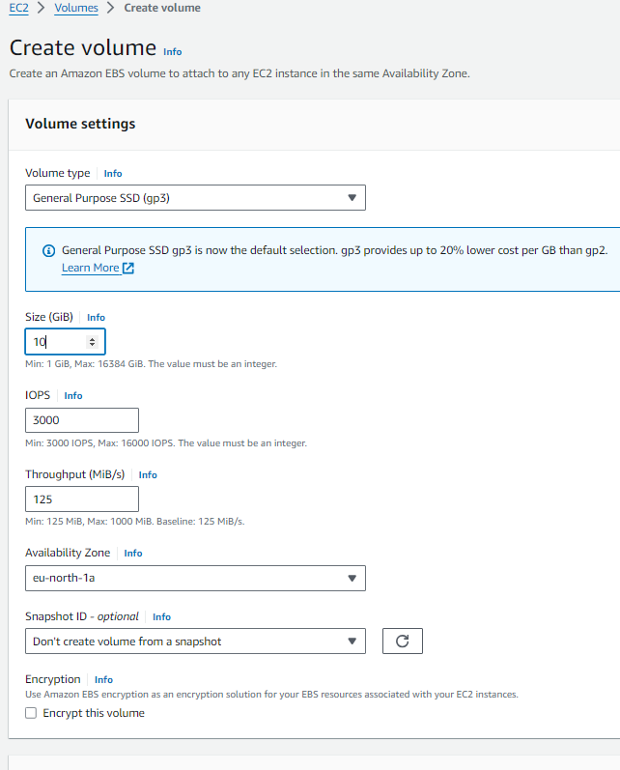

I was created the volume with 10GiB.once created the volume attach the volume to the EC2 instance(instance 1). Ec2 instance and created EBS volume should be same availability zone then only we can able to attach the volume to the EC2 instance

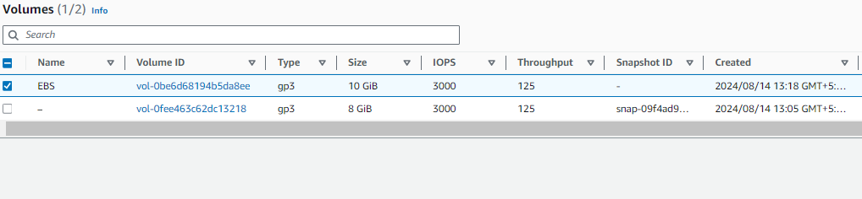

After created go to actions and attach ec2 instance using device name as /dev/sdf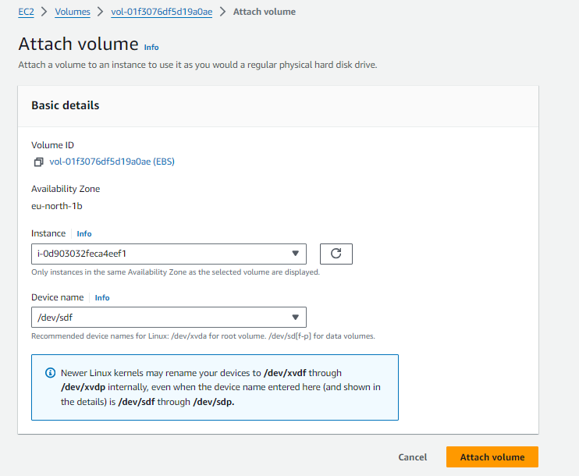

* And then click on attach volume.
* Now for EC2 instance total storage will be 18GiB(8 GiB default storage+10 GiB attached volume).
* Attached volume will be available in block storage, for checking that storage in git bash use lsblk command.
* For checking is there any file system in device ->file -s /dev/xvdf
* For creating file system ->mkfs -t xfs /dev/xvdf
* Creating a nested directory->mkdir -p apps/volume
* For mounting the storage block storage to the root storage, we need to use Mount /dev/xvdf apps/volume.
* After mounting the storage total output storage for the root user is 18 GiB as shown in below.

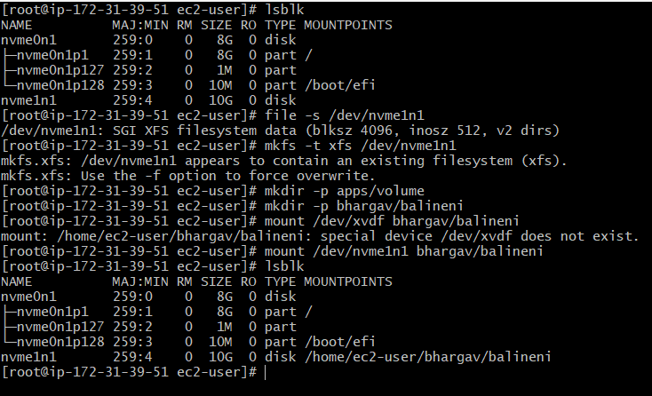

Same we need to create another EC2 instance and attach to the EBS volume after detaching from the instance 2.

* **Conclusion:**
* Elastic block storage is a scalable, high-performance and block storage service designed for amazon EC2 and it can be attached or detach from EC2.
* EBS and EC2 instances both are in same availability zone only we can able to attach or detach the volume.
* Multiple EBS can attach to the single EC2 instance but multiple EC2 instances can’t able to attach to the same EBS.

**B. Bhargav**

[**bargavrambalineni@gmail.com**](mailto:bargavrambalineni@gmail.com)